Chapter 16, Problem 105.

A gyrator is a device for simulating an inductor in a network. A basic gyrator circuit is shown in Fig. 16.113. By finding V_{i}(s)/I_{o}(s), show that the inductance produced by the gyrator is L = CR².

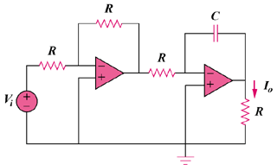

Figure 16.113
For Prob. 16.105.

